ASSIGNMENT-12.4
Course: AI Assisted Coding
Name: B. Divya Sri
HT NO: 2403A51425
Batch- 16
Screenshots:
Task 1:
Prompt:
write a python program bubble sort using doc strings and inline comments.please consider one example.
Code & Output:
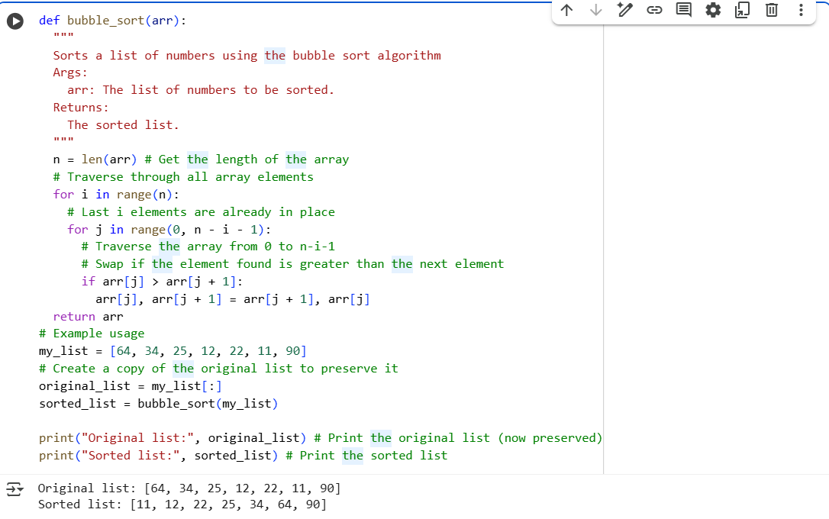

Task 2:
Bubble sort Code:


Insertion sort code:
Prompt:
Write the alternative(insertion sort) for the previous program .
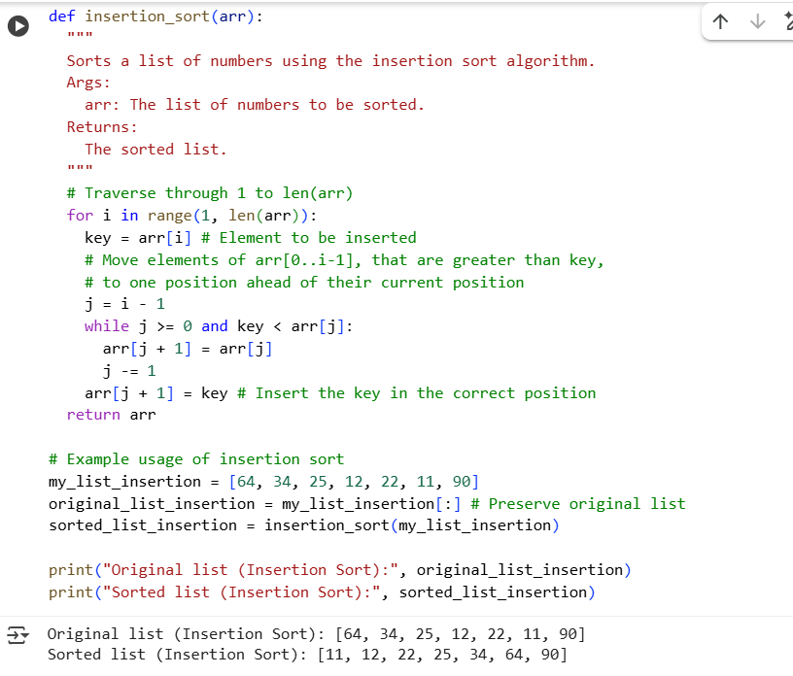
Comparision:
- How they move numbers: Bubble sort "bubbles" the largest unsorted number to its correct place in each pass by swapping adjacent items. Insertion sort takes one unsorted number and "inserts" it into its correct place within the already sorted part of the list.
- Efficiency for mostly sorted lists: Insertion sort is generally faster than bubble sort if the list is already almost sorted. Bubble sort will still do many comparisons even if the list is nearly sorted.
- How they stop: The basic bubble sort always goes through all the passes. The optimized bubble sort and insertion sort can potentially finish earlier if the list becomes sorted before the maximum number of passes.

Task 3:
Prompt:
Write a program that implements linear search.
Code & output:
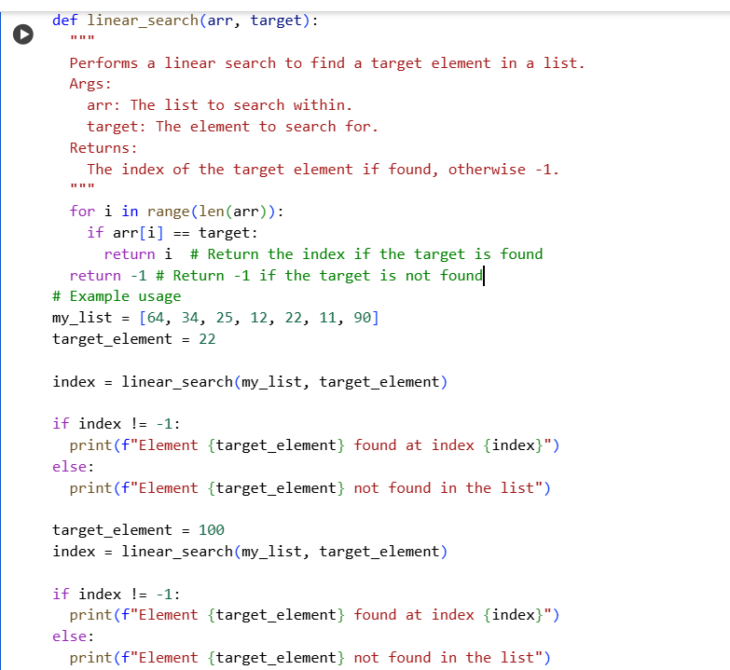

Prompt:
Write a program that implements binary search.
Code& Output:
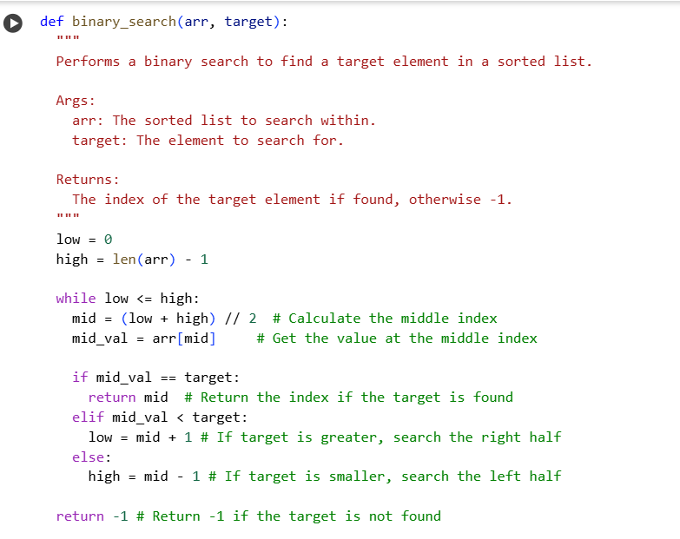
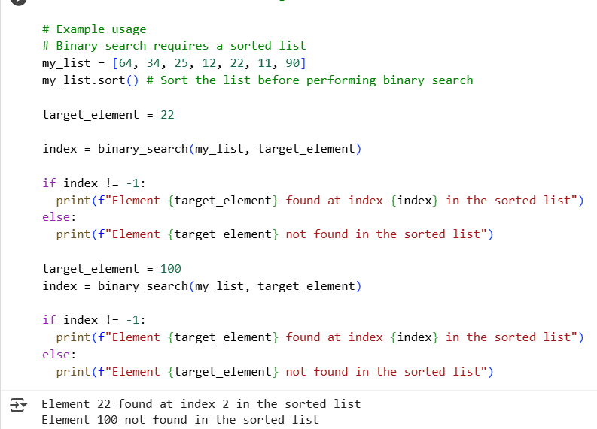
Comparision of linear search and binary search:
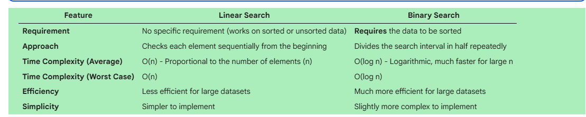
Task 4:
Prompt:
Write a python program that implements quick sort .consider one example.
Code& Output:
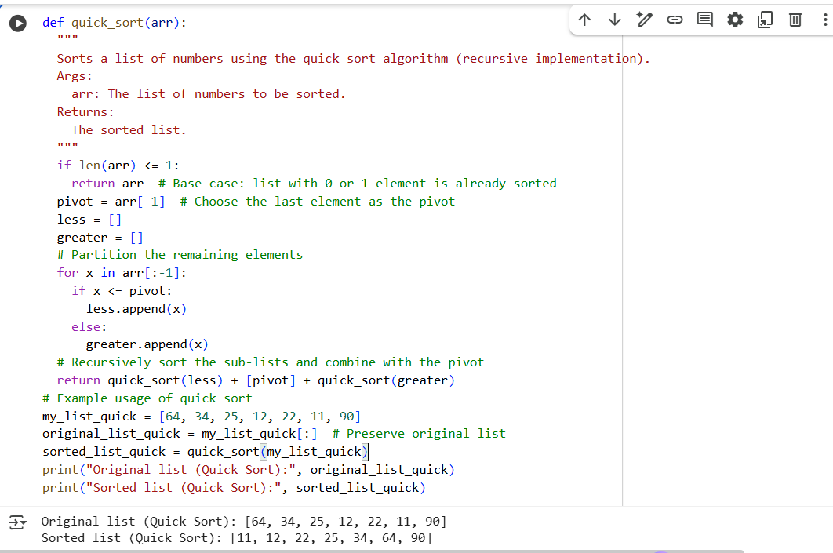
Prompt:
Write a program in python that implements merge sort.consider one example.
Code & Output:
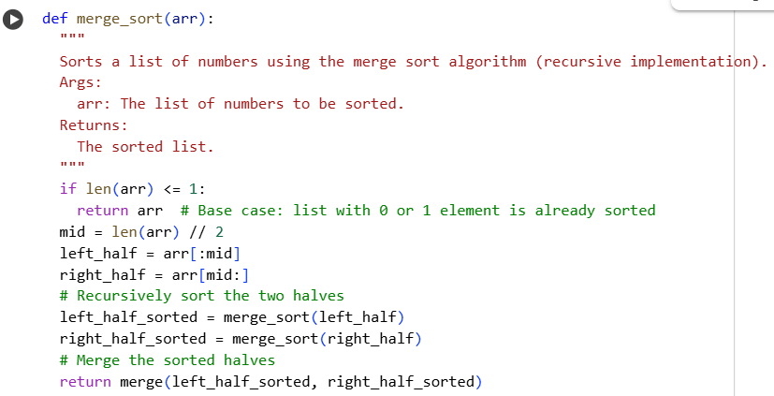
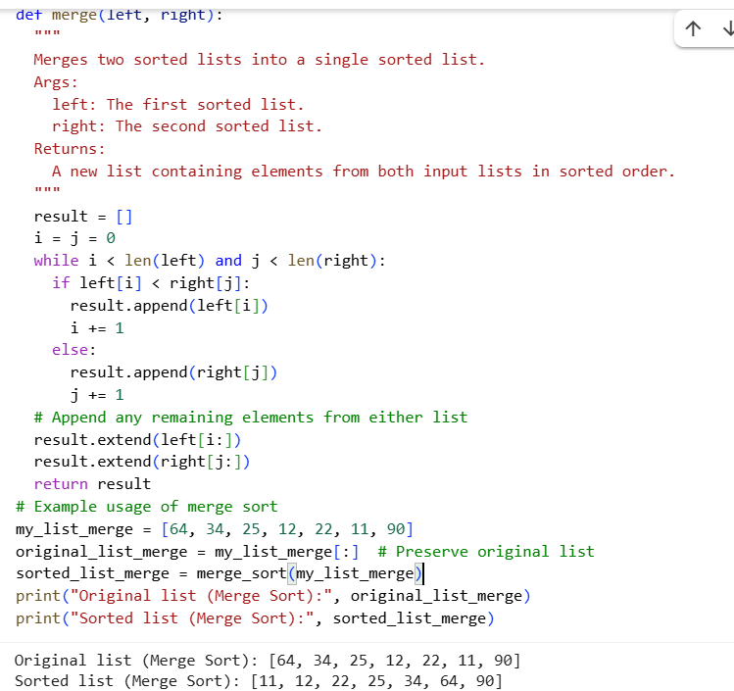
Comparision:
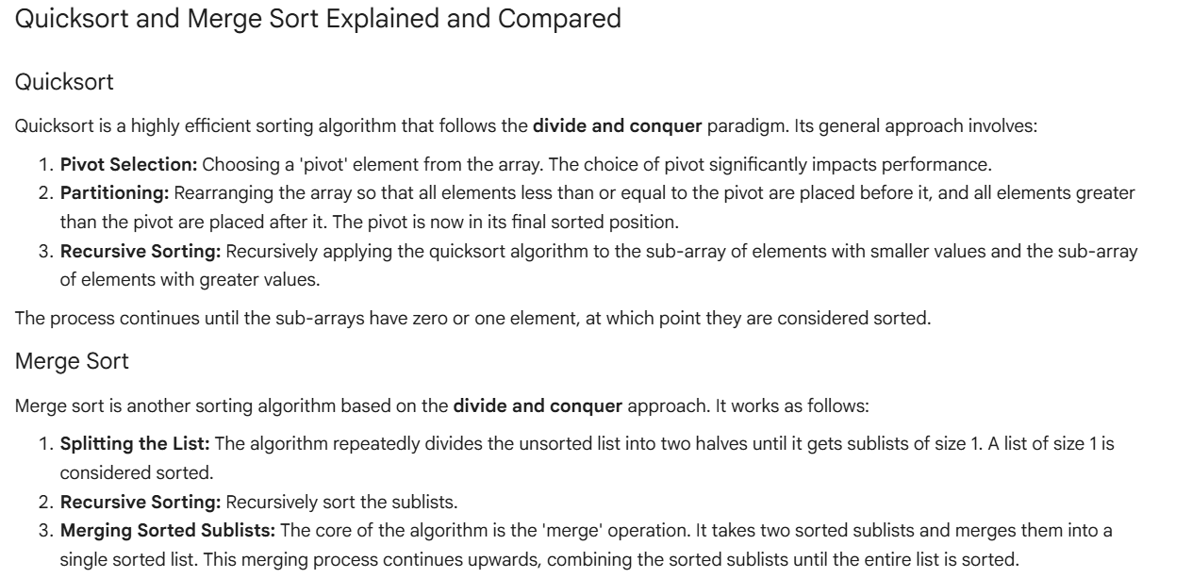
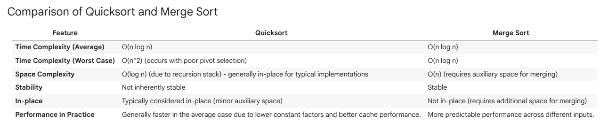
Task 5:
brute force duplicate-finder
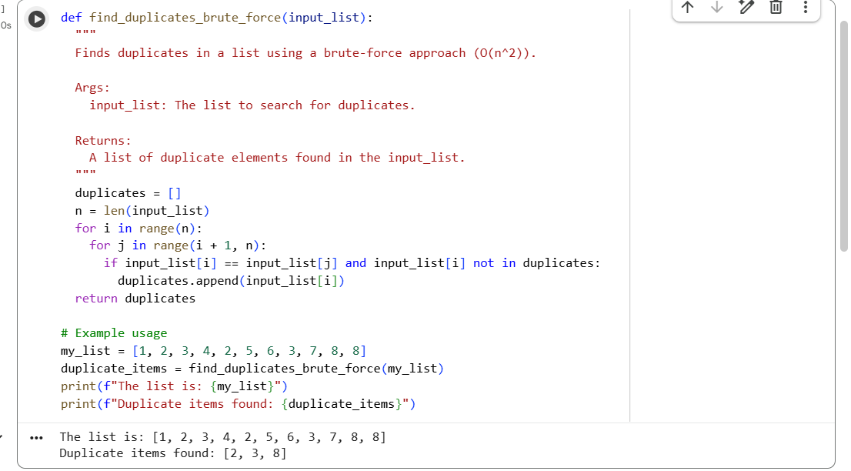
AI Suggested Optimization :
Prompt:
Optimize this code by using sets/dictionaries with O(n) time).
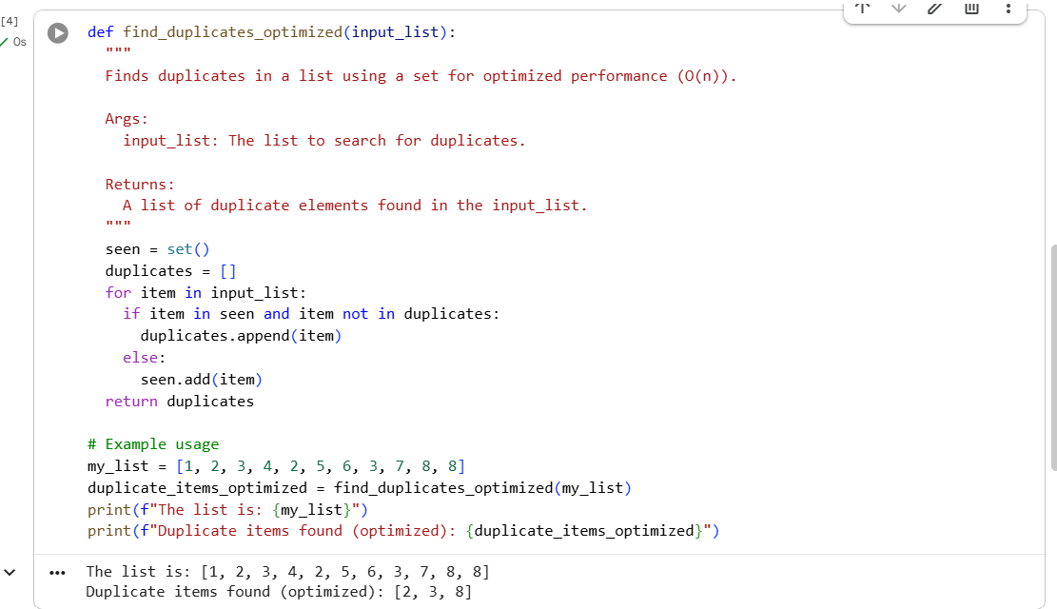
Explanation of how complexity improved:
The improvement in time complexity comes from the change in how we check for duplicates.
- Brute-force approach (O(n²)): This method uses nested loops. For each element in the list, it compares it with every other element. If the list has n elements, the inner loop runs approximately n times for each element in the outer loop, resulting in roughly n * n comparisons. As the list size grows, the number of operations increases quadratically.
- Optimized approach (O(n)): This method uses a set to keep track of elements seen so far. Checking if an element is in a set is, on average, a constant time operation (O(1)). We iterate through the list only once. For each element, we perform a quick check in the set and either add it to the seen set or to the duplicates list. The number of operations is directly proportional to the number of elements in the list, hence the linear time complexity.

